**5.2 Building Continuous Integration Pipelines In Jenkins**

This section will guide you to:

* Build Continuous Integration Pipelines in jenkins

This lab has two sub-sections, namely:

5.2.1 Building a Maven project

5.2.2 Creating a Pipeline to build the project

**Step 5.2.1:** Building a Maven project

* Login to your Github account.
* Click on the plus icon next to the profile picture and select *New repository* from the drop-down menu.

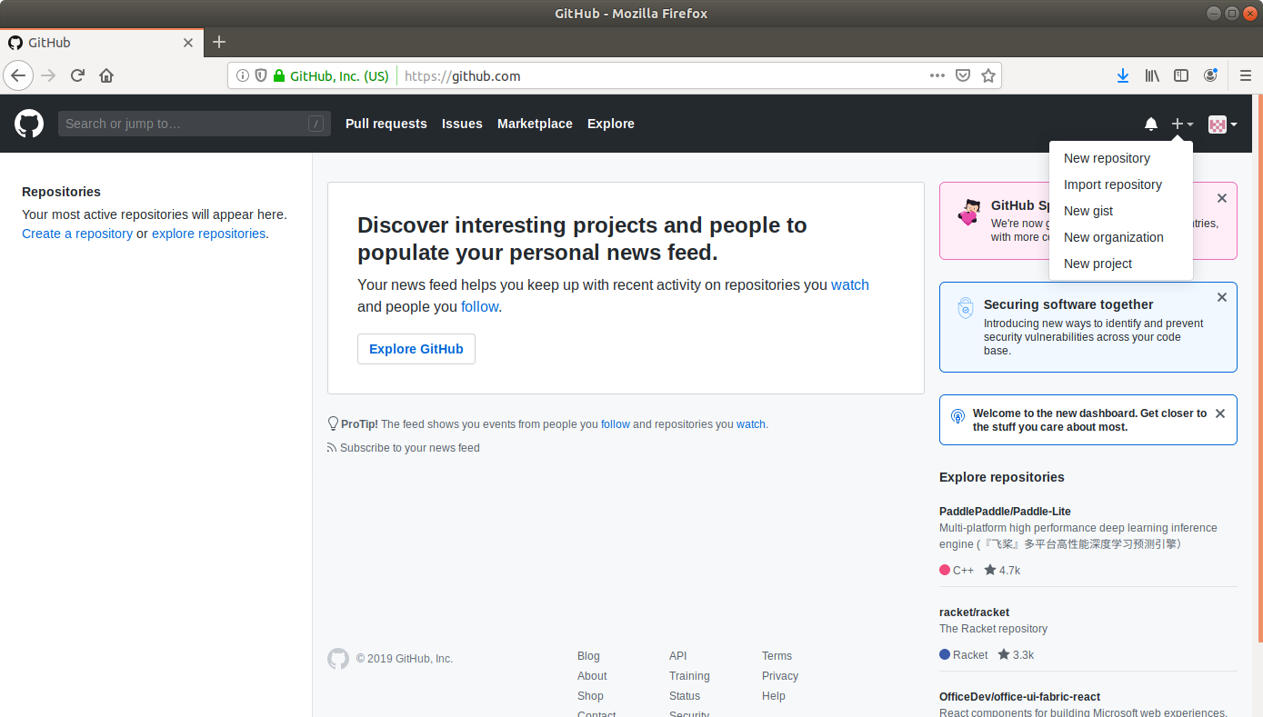

* Fill the required fields in the create repository form.
* Click on the **Create Repository** button.
* Click on the **Clone or download** button and copy the URL.
* Go to ​start.​spring.​io/​

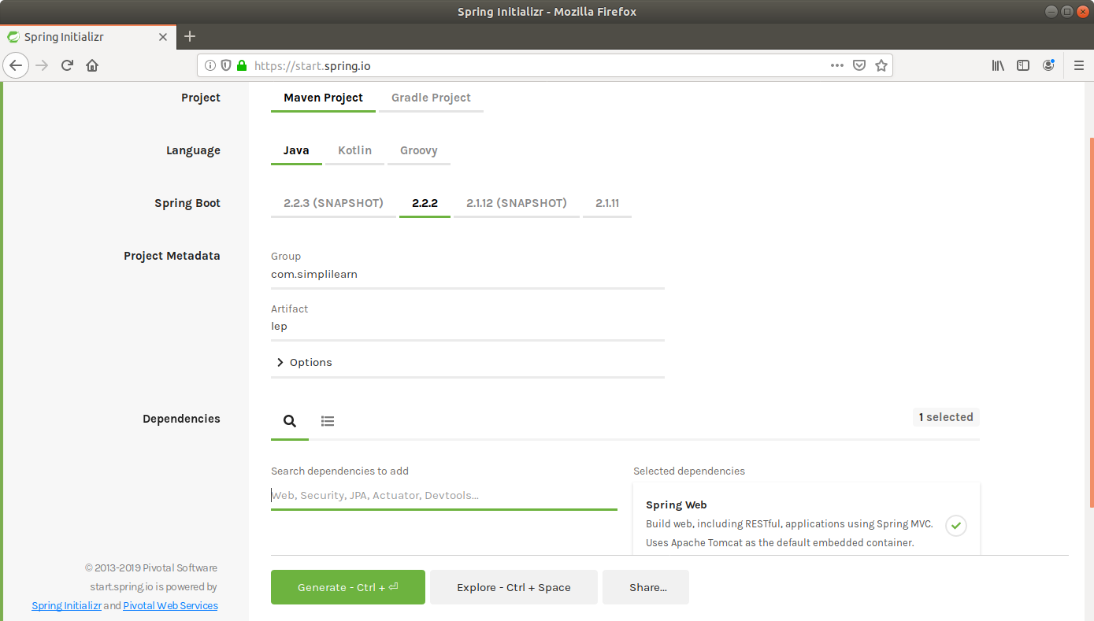

* Select Maven as the project type.
* Fill Group and Artifact with appropriate values. For example, *com.simplilearn* and *Calculator.*
* Add **Web** to Dependencies.
* Click on **Generate Project.**
* The generated skeleton project should be downloaded as a zip file.
* Open the terminal and navigate to an appropriate location.
* Run **git clone [URL]** to clone the repository.
* Unzip the downloaded spring boot project to the cloned repository.
* Commit the changes to the remote SCM.
* Run **git add .**
* Run **git commit -m “Add logic and test”**
* Run **git push -u origin master**

**Step 5.2.2:** Creating a Pipeline

* Go to Jenkins dashboard.
* Click on *New Item*.
* Enter a name for your build job.
* Select Pipelineas the build job type.

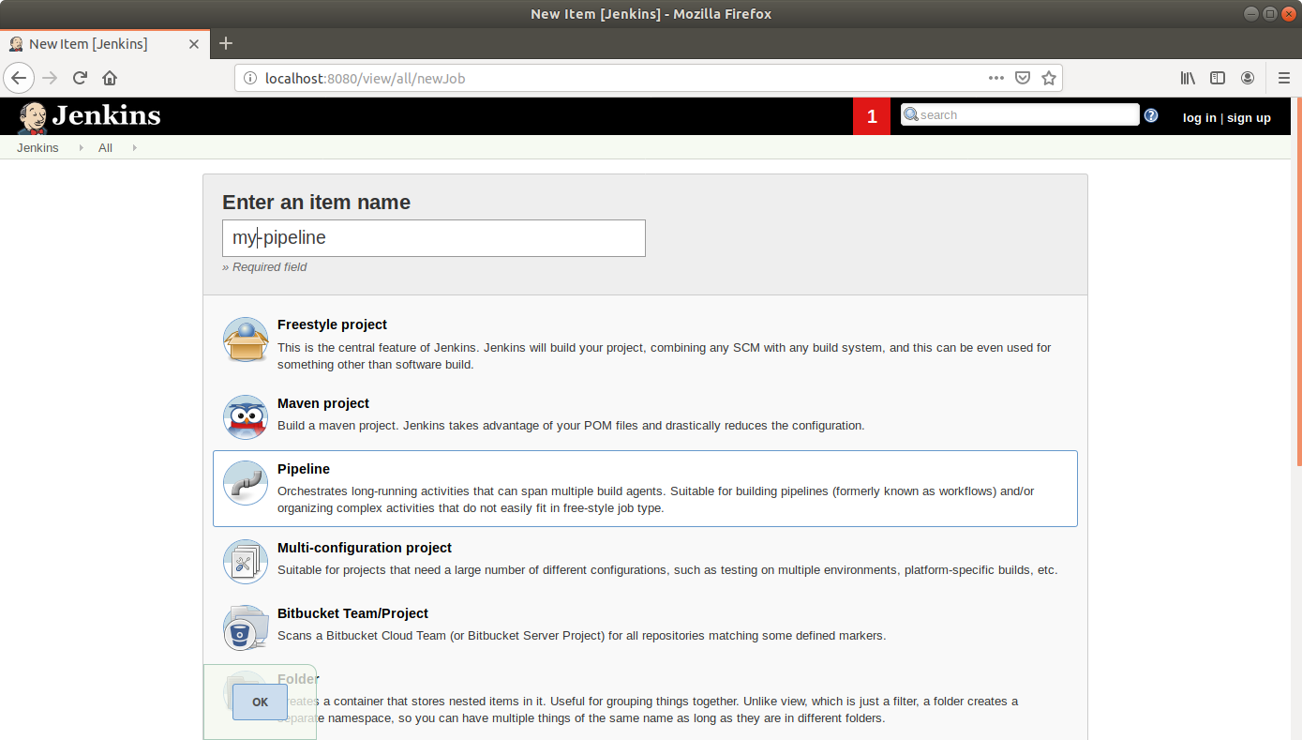

* Click OK.
* Scroll down to the Pipeline section and enter the script below:

**pipeline {**

**agent any**

**tools {**

**maven 'my_mvn'**

**}**

**stages {**

**stage("Checkout") {**

**steps {**

**git url: 'https://github.com/judy-simplilearn/Calculator.git'**

**}**

**}**

**stage('Build') {**

**steps {**

**sh "mvn compile"**

**}**

**}**

**stage("Unit test") {**

**steps {**

**sh "mvn test"**

**}**

* Click Save.

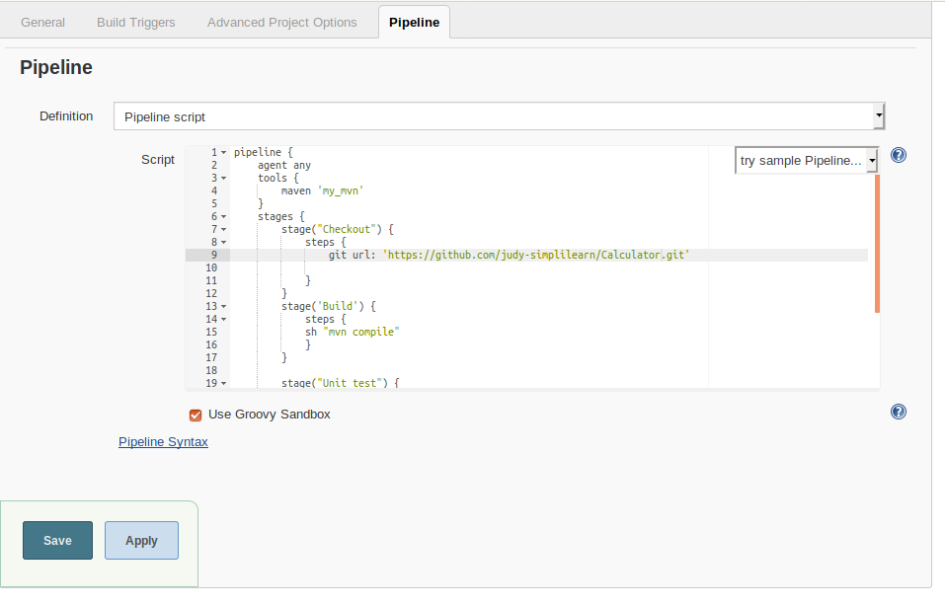

* Click *Build Now* in the project window to make sure that the build works. Jenkins will now build your project.
* Click on the *Build History* to view the build results.
* Click on the *Logs* to view the build logs in each stage.

